**Gates**

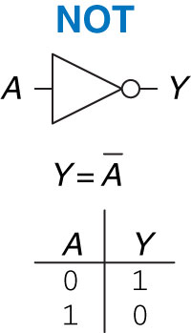 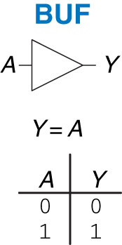 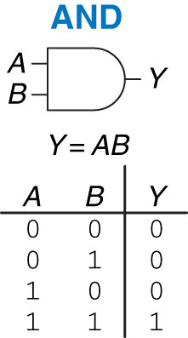 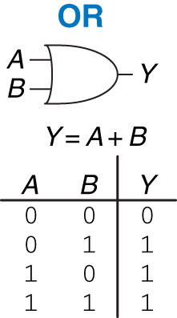

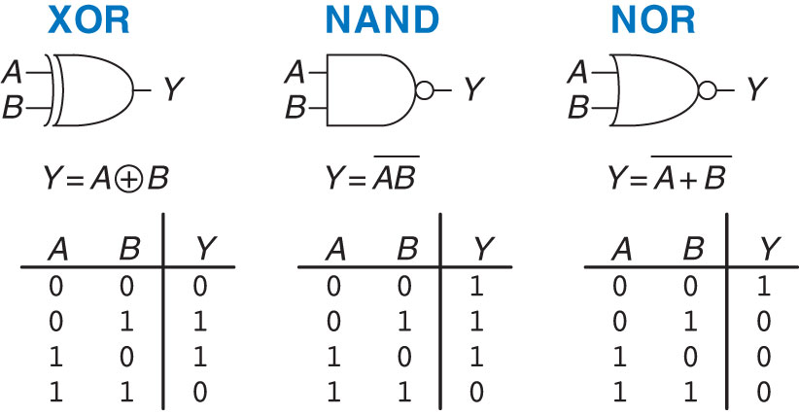

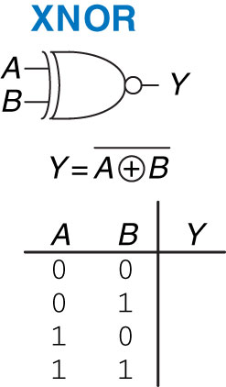 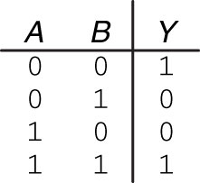

**Multiplexer**

|  |
| --- |
| **If S == 0 then Y = D0**  **If S == 1 then Y = D1** |

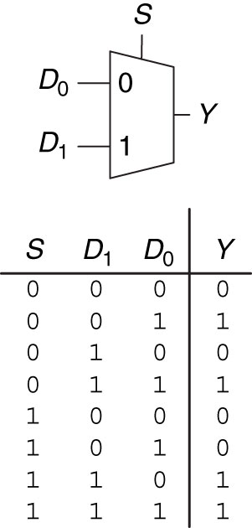 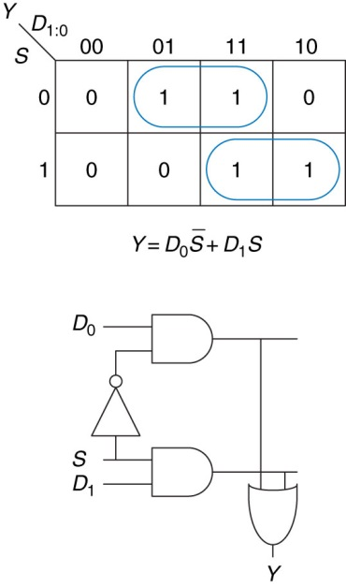

**Decoder**

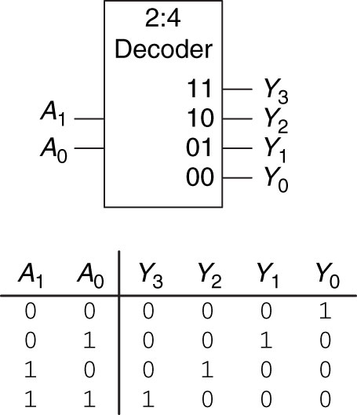 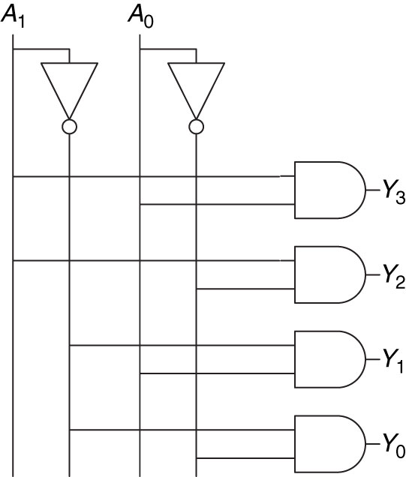

**SR latch**

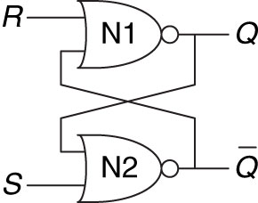 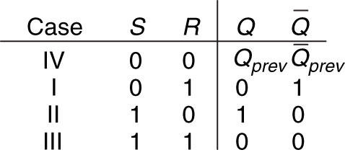

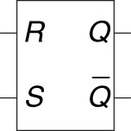

**D latch**

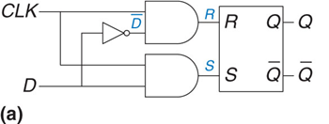 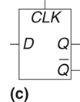

|  |
| --- |
| **If CLK == 1 then set D = X**  **If CLK == 0 then select Q** |

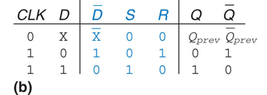

**D flip-flop**

|  |  |  |  |  |  |  |
| --- | --- | --- | --- | --- | --- | --- |
| **CLK** | **D** | **-D** | **S** | **R** | **Q** | **-Q** |
| **0** | **X** | **X** | **0** | **0** | **Qp** | **-Qp** |
| **1** | **0** | **1** | **0** | **1** | **0** | **1** |
| **1** | **1** | **0** | **1** | **0** | **1** | **0** |

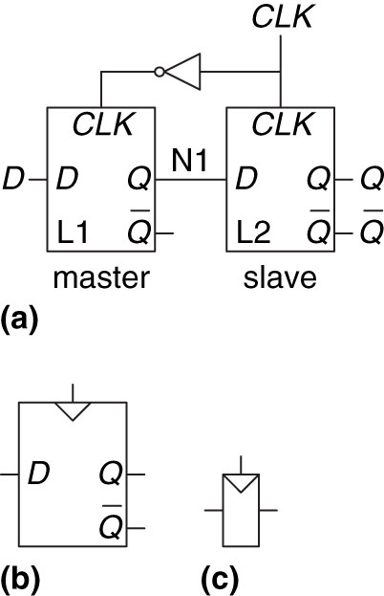

**4-bit register**

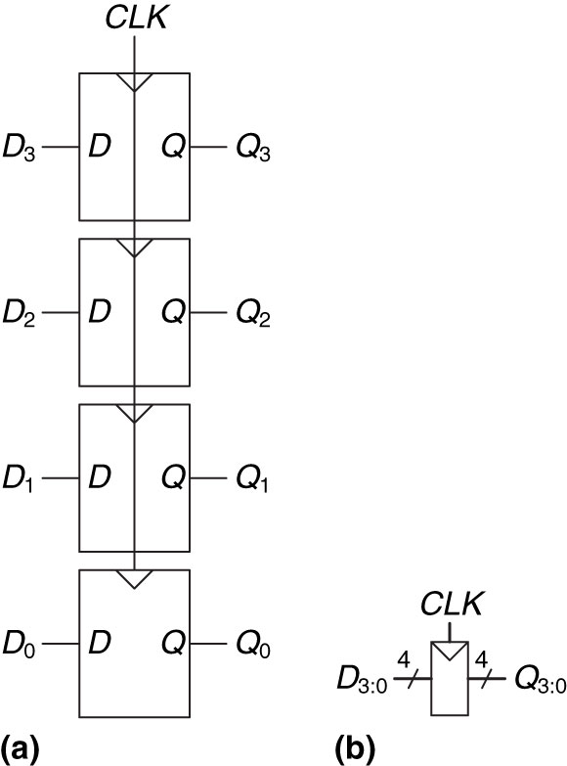

**Enabled flip-flop**

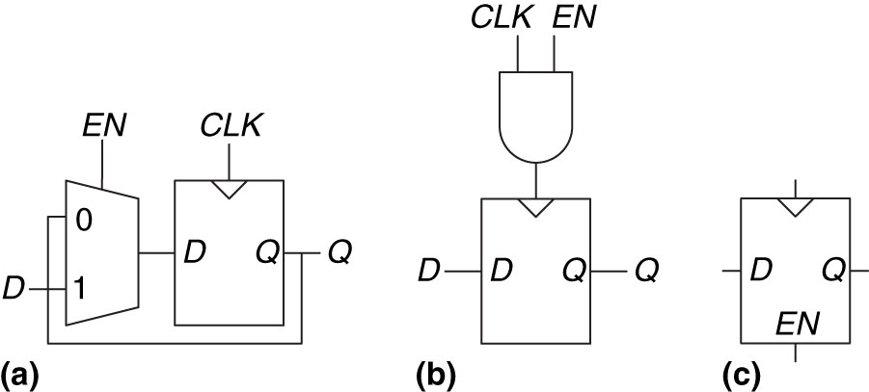

**Synchronously resettable flip-flop**

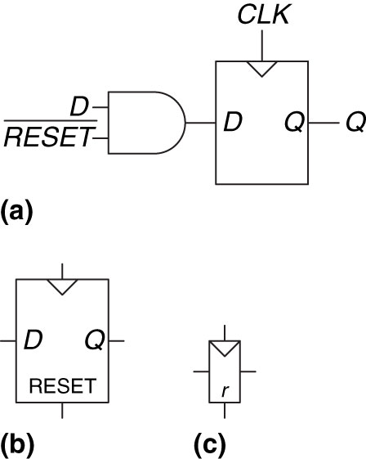

**1-bit half adder**

|  |
| --- |
| **Carry bit** |

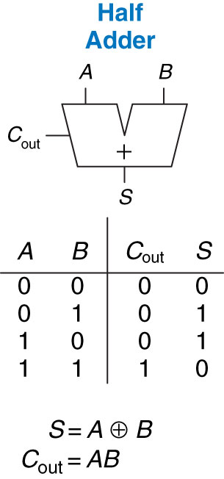

**1-bit full adder**

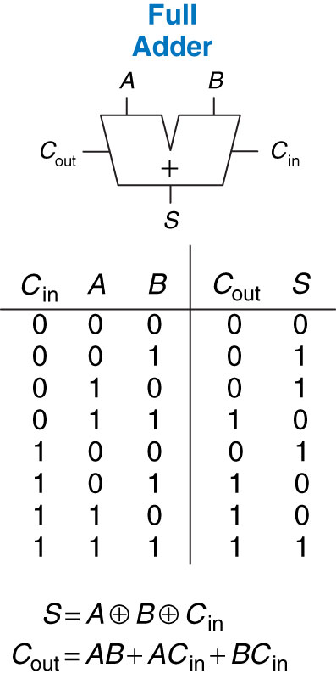

**Carry propagate adder**

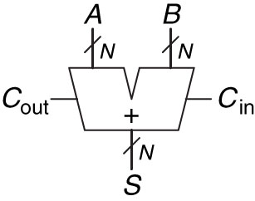

**32-bit ripple-carry adder**

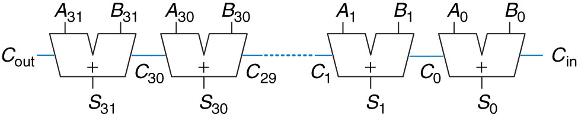

**Subtractor**

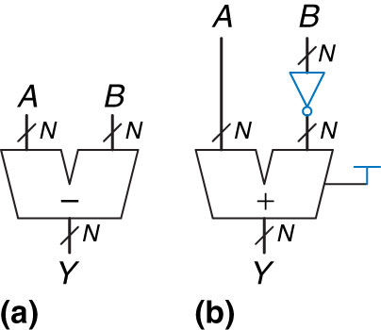

***N*-bit magnitude comparator**

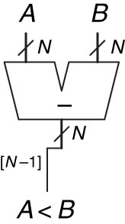

**ALU**

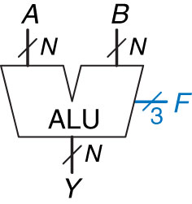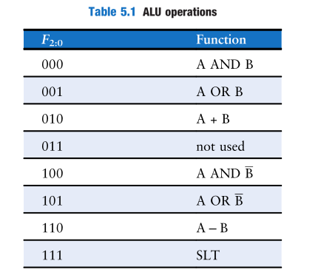

***N*-bit ALU**

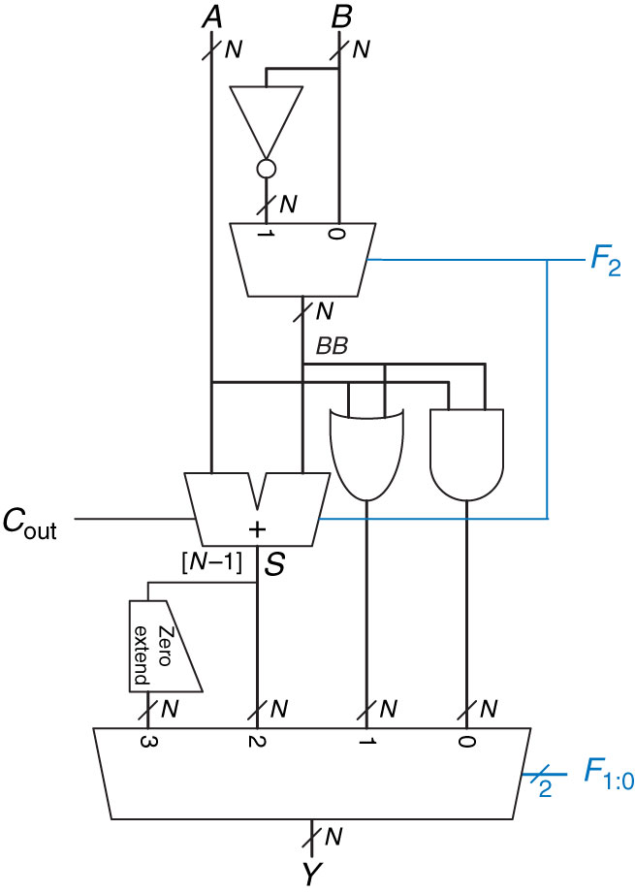

**Counter**

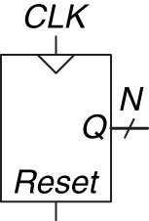

***N*-bit counter**

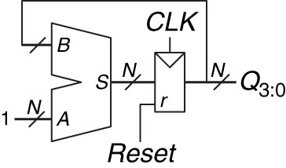

**Shift register**

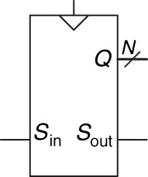

**Shift register**

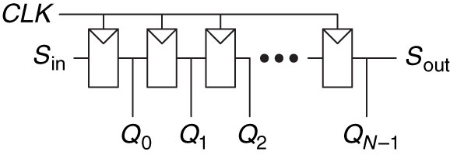

**Scannable flip-flop**

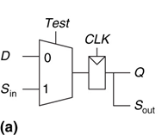 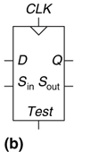

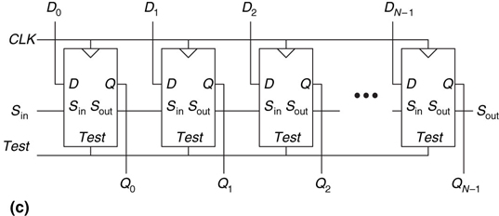

**Generic memory array**

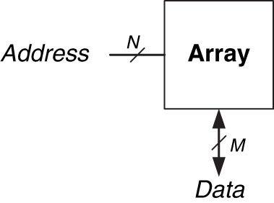

**4-3 memory array**

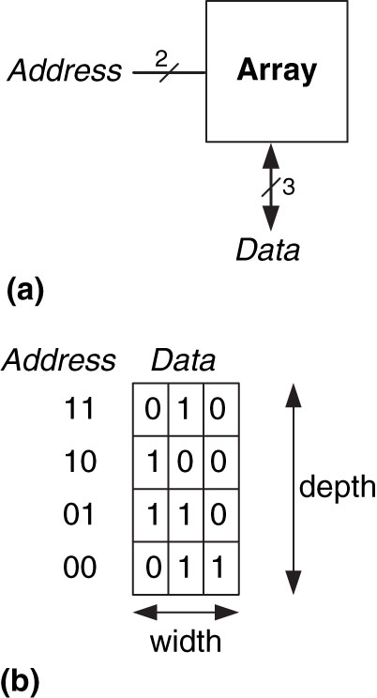

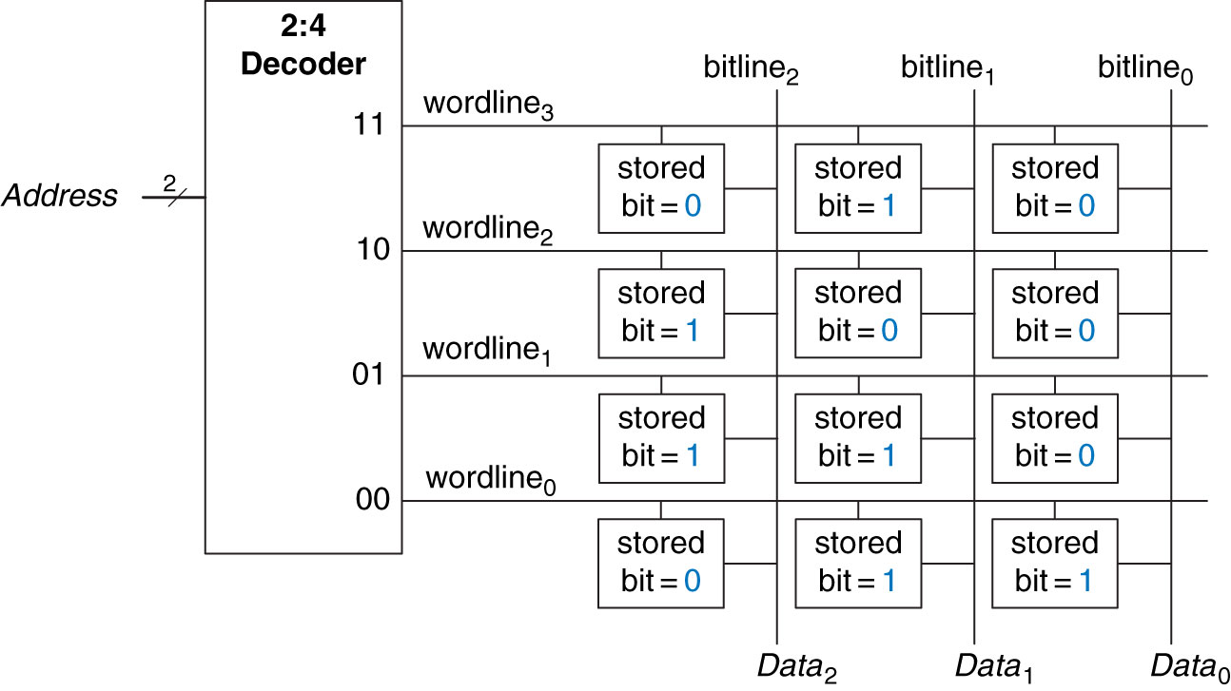

**32 Kb array: depth = 210 = 1024 words, width = 32 bits**

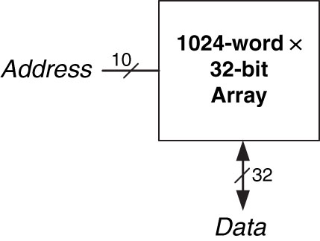

**DRAM stored values**

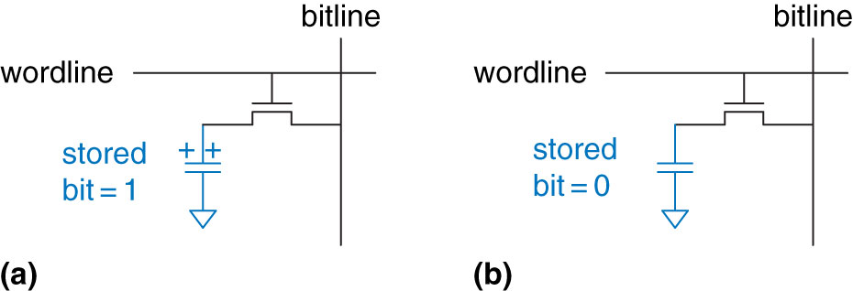

**SRAM bit cell**

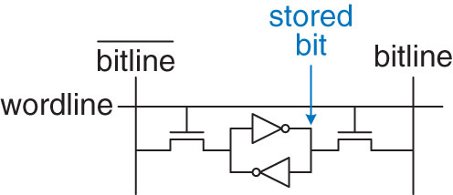

**32-32 register file with two read ports and one write port**

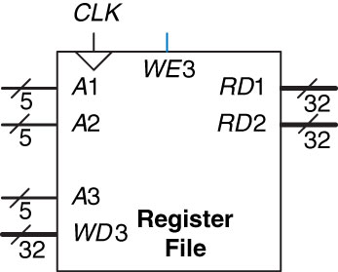

**4-word 1-bit memory array used as a lookup table**

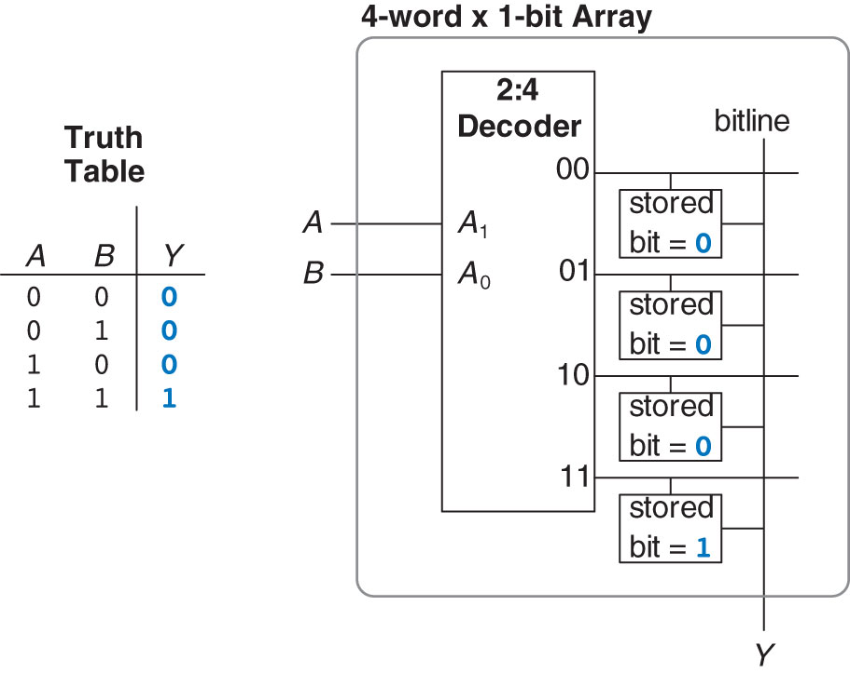

**Cyclone IV Logic Element (LE)**

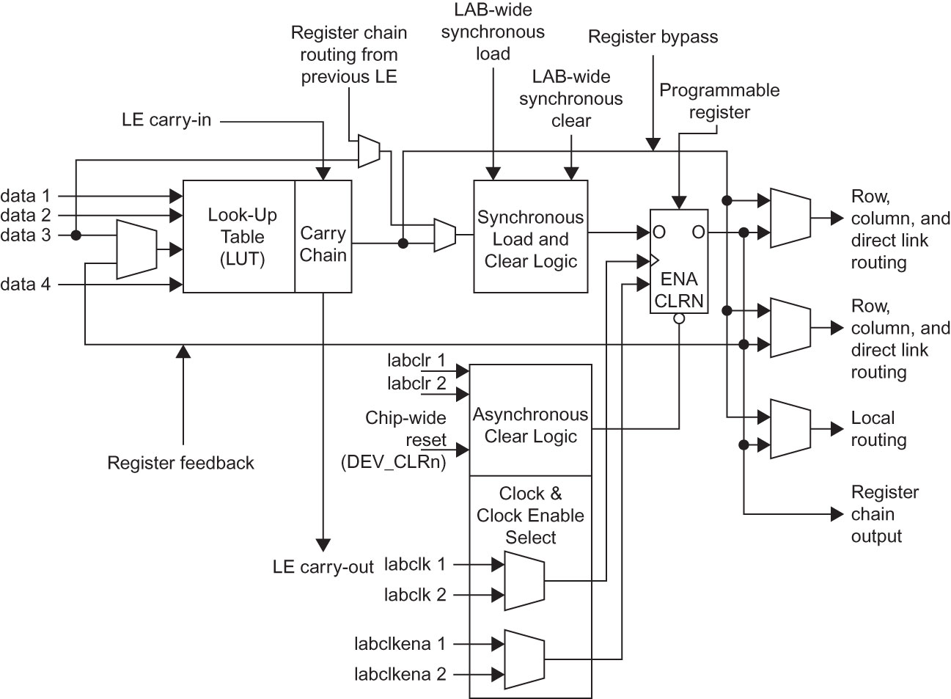

[**http://booksite.elsevier.com/9780123944245/?ISBN=9780123944245**](http://booksite.elsevier.com/9780123944245/?ISBN=9780123944245)